MapleSyrup
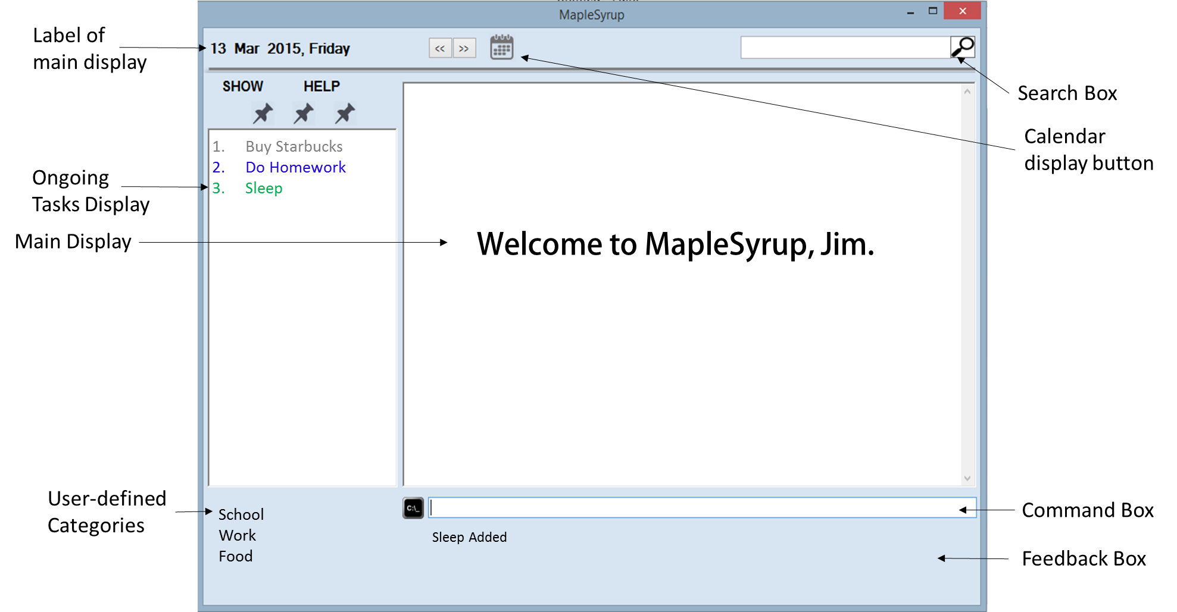
Supervisor: Lim Yu De Extra feature: GoodGUI
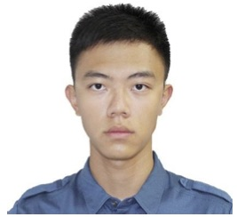  Ong Wei Jee  Team Lead  Code Quality |   George Lam Changwei  Github Expert  Documentation |   Ter Yong Kang  GUI Designer  Deliverables and Deadlines |   Che Jian Yong Joshua  Integration  Scheduling and tracking

User guide

Introduction
Welcome to MapleSyrup, your go to application to keep track of tasks and events. An event in MapleSyrup consists of several details: the name, date, time and additional descriptions. In this guide, we will walk through the process of adding, deleting, editing, displaying events, undoing and redoing.
Getting Started
- Double click MapleSyrup on your desktop.
- A welcome message will appear to greet you when the program opens.
- The main display will show all your tasks and events for today. On-going tasks will be permanently displayed on the left column.

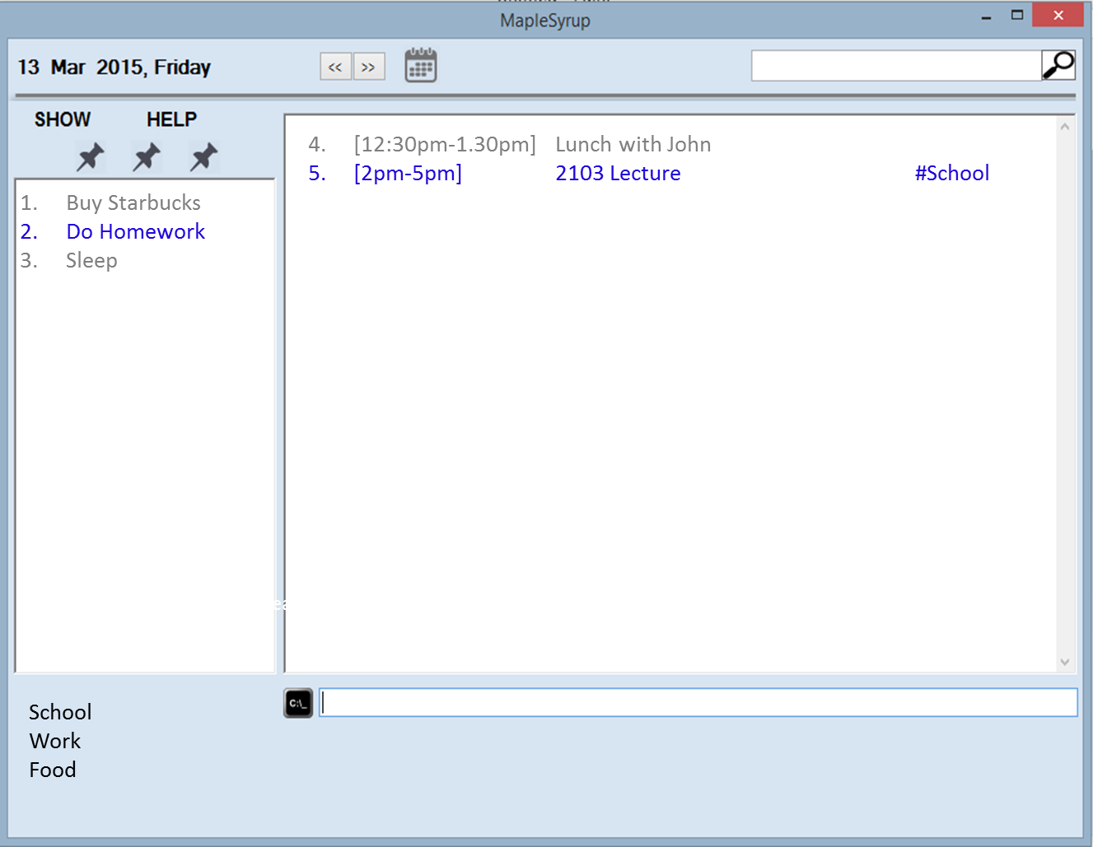

Functions
ADDING AN EVENT:
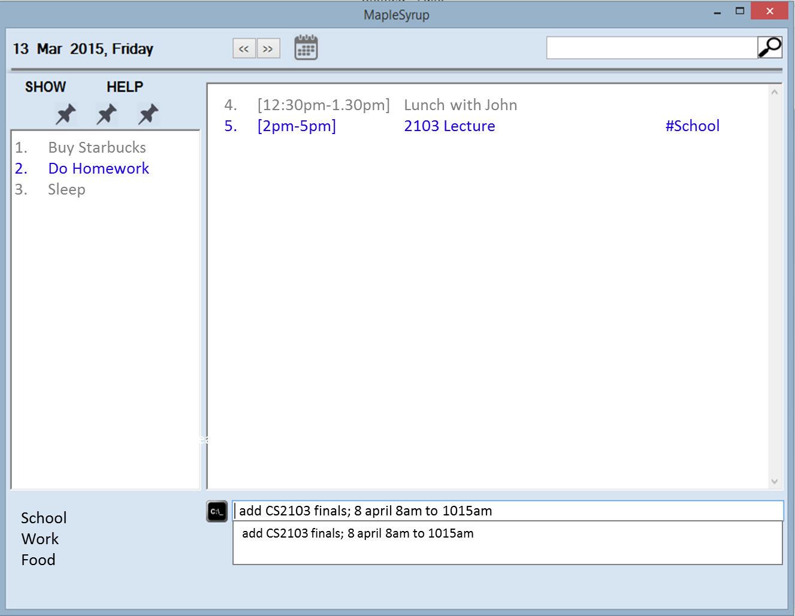
- For single day events, type “add” followed by the “event name” and “;” followed by the time and duration of the event. For example, “add CS2103 finals; 8 april 8am to 1015am”.
- A feedback box will display an acknowledgement “CS2103 finals added.”
- In addition, the main display will show the newly added event in green with the rest of the events you have on that day, as seen in the picture below.
- When typing a command, a suggestion box will appear to prompt correct input formats. There are a total of 9 types of events that can be added, depending on your event’s characteristic. Below are the 9 types with example.
- Event Name only (add Pick up laundry)
- Today Event with starting time only (add Go for a run; 9am)
- Today Event (add Dinner at Koufu; 8pm-10pm)
- Single Day Event with starting time (add Dental Appointment; 18 feb 4pm)
- Single Day Event (add Breakfast with Joshua; 8 feb 8am to 1015am)
- Full Day Event (add Beach Day; 20mar)
- Full Day Event spanning a few days (add Summer Camp; 15 march to 20 april)
- Event spanning a few days with starting time (add Queue for new Iphone; 7 dec to 19dec 10am)
- Event spanning a few days (add Holiday; 17 april to 19 april from 9.30pm to 11.45pm)

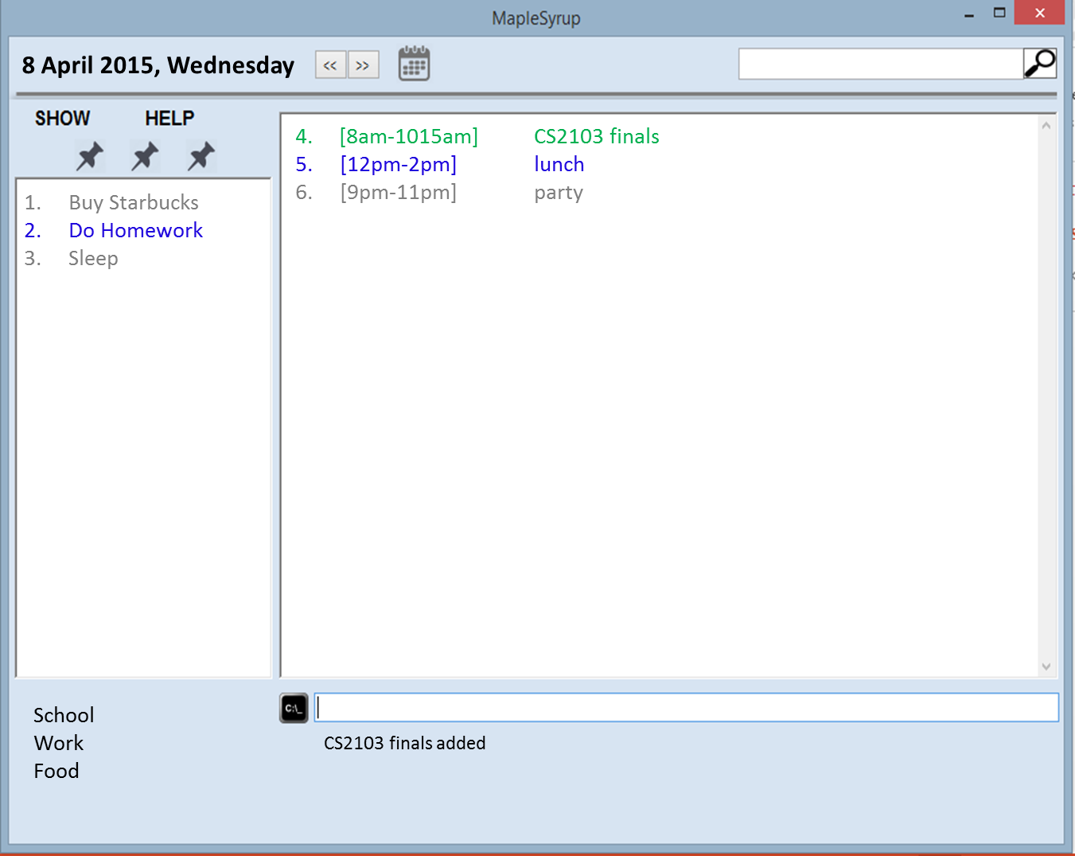

- If the new event clashes with an existing event, both clashed events (old and new) will be shown in red.

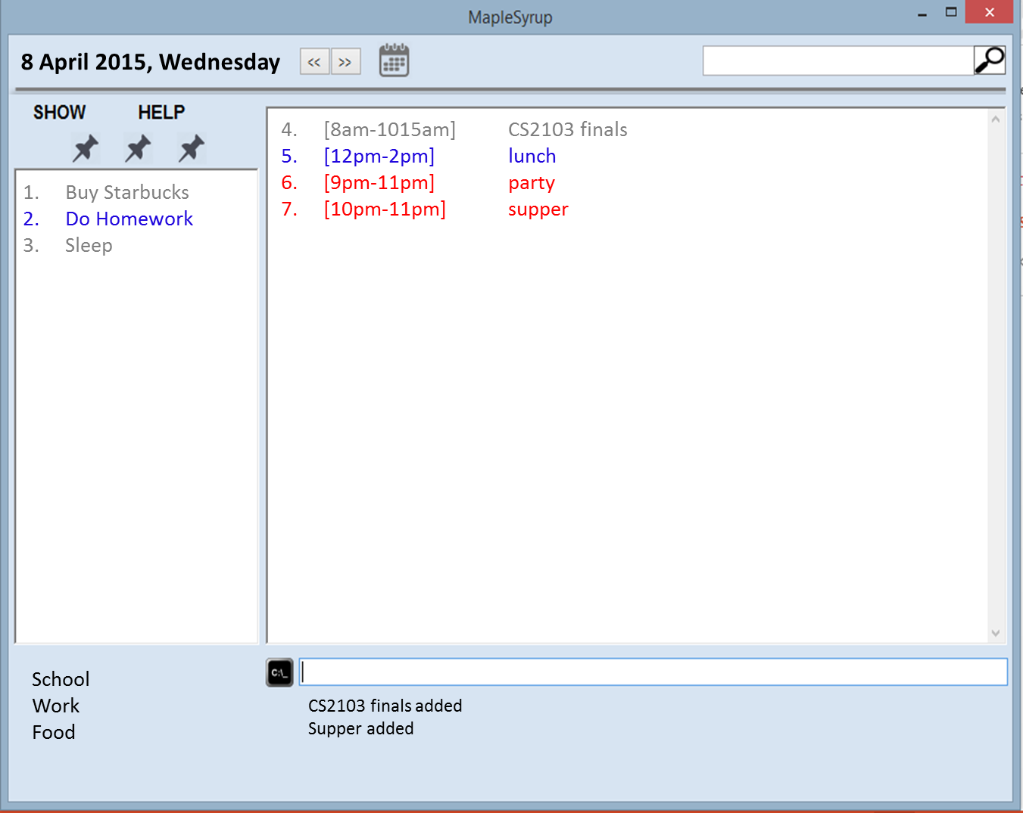

SEARCHING FOR AN EVENT
- Type into the search bar at the top right of the window to search for the event. You can search for event name, date, description or tags.
- The top left box will show the label of what is being displayed on the main display which you have just searched.
- Search results will be presented on both the main display panel and sub panel.

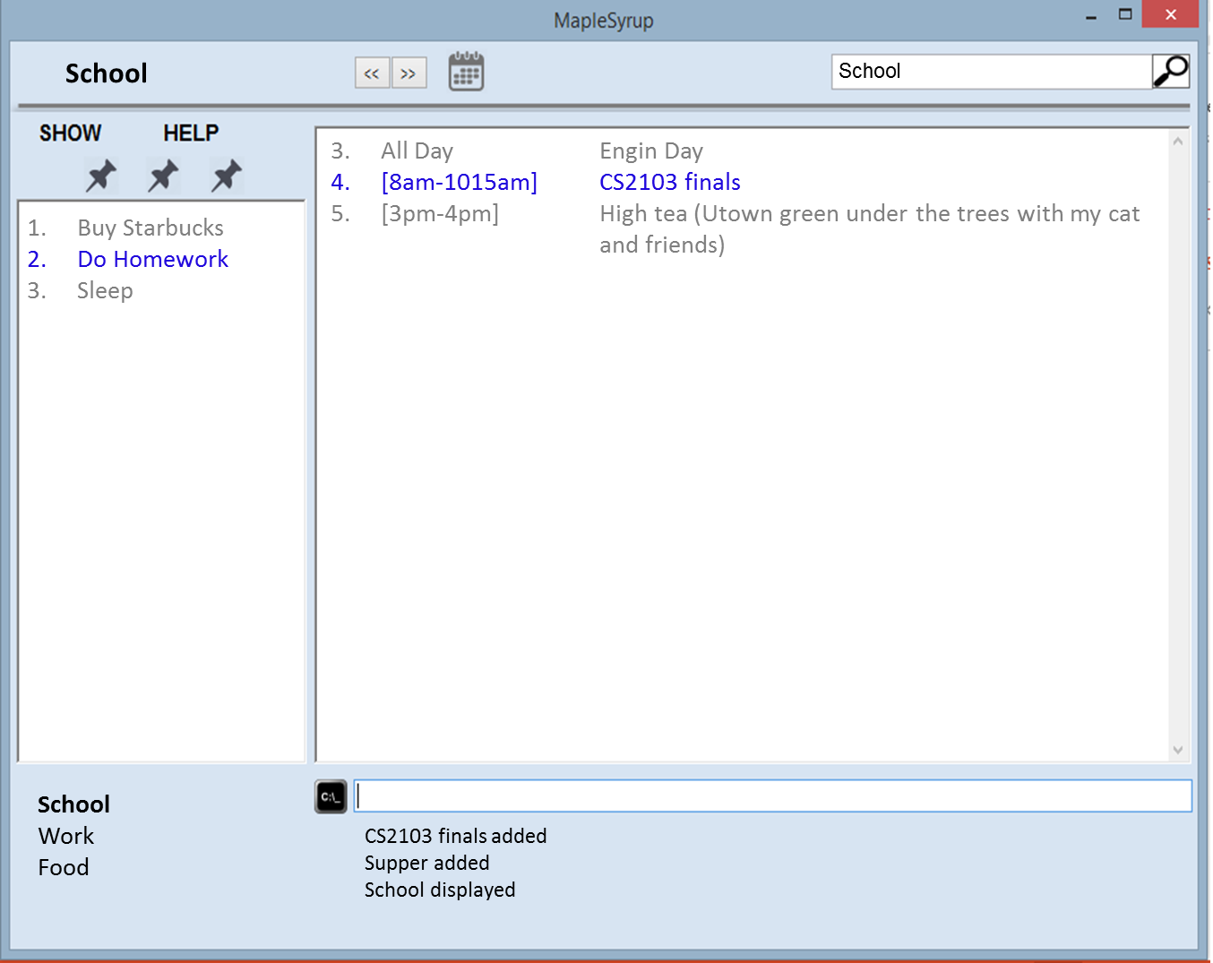
EDITING AN EVENT
- To edit and event, type “edit” and suggestion Box will appear to prompt the correct input format.
- There are 2 main methods to edit an event:
- Edit from display’s index.
- Edit with event name.
- These are the recognized methods to edit, with examples in brackets.
- Edit from Index (edit 3 CS2103 V0.5)
- Edit Name (edit CS2103 finals; CS2103 V0.5)
- Edit Time: (edit CS2103 finals; 9am)
- Edit Dates: (edit Holiday; 21mar)

- Multiple Edits
- Edit name, dates, time (edit Run; Jog; 10feb 9am-10am)
- Edit name, time (edit 1 Dinner at Koufu; 10pm)
- Edit name, date (edit Holiday; Bangkok!; 11feb to 15feb)
- Edit date, time (edit 3 10 feb 11.30am to 11 feb 11.30pm)

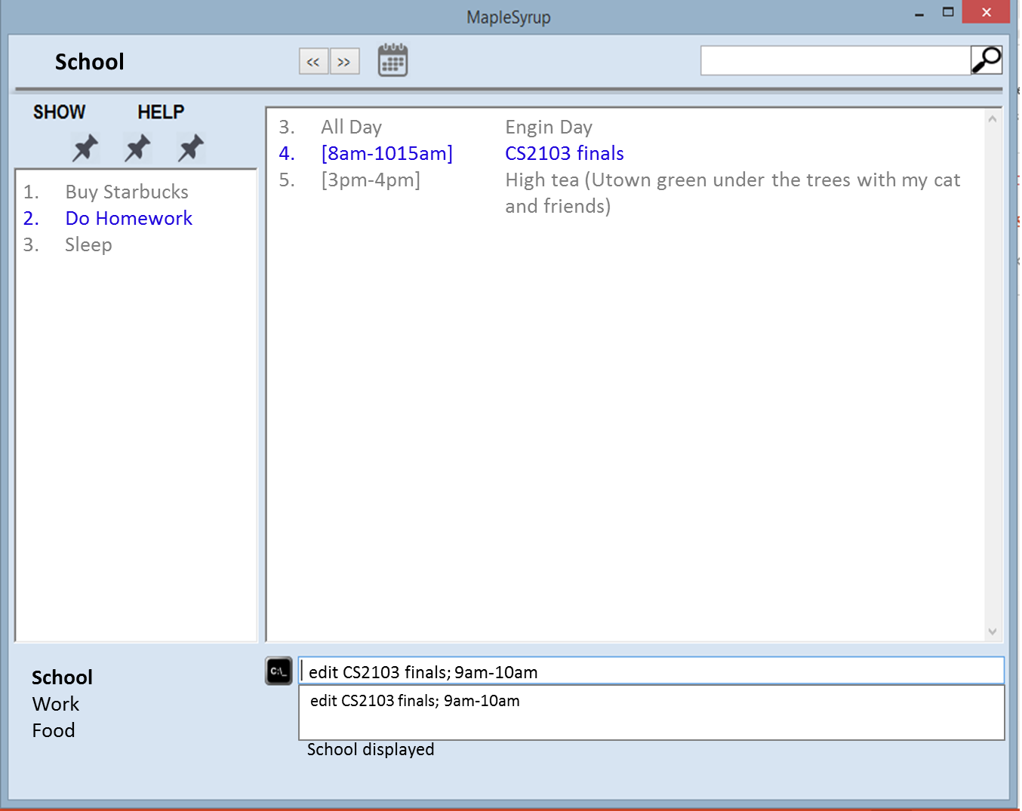

- Feedback box will display an acknowledgement “[Name of event] edited.” As seen below.

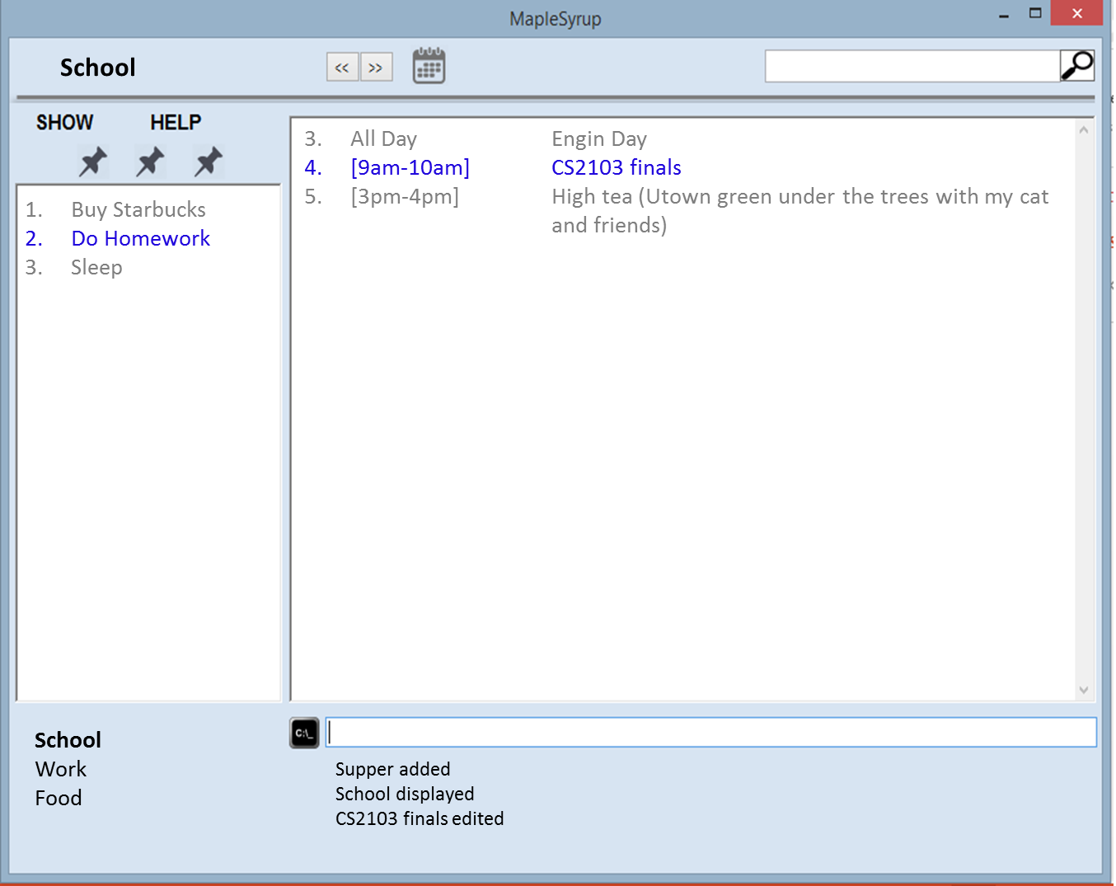

DELETING AN EVENT
- Type ‘delete’ and suggestion Box will appear to prompt you the correct format of input.
2. There are 2 main methods to delete an event:
1. Delete from display’s index (delete 5).
2. Delete with event name (delete 2013 Lecture).
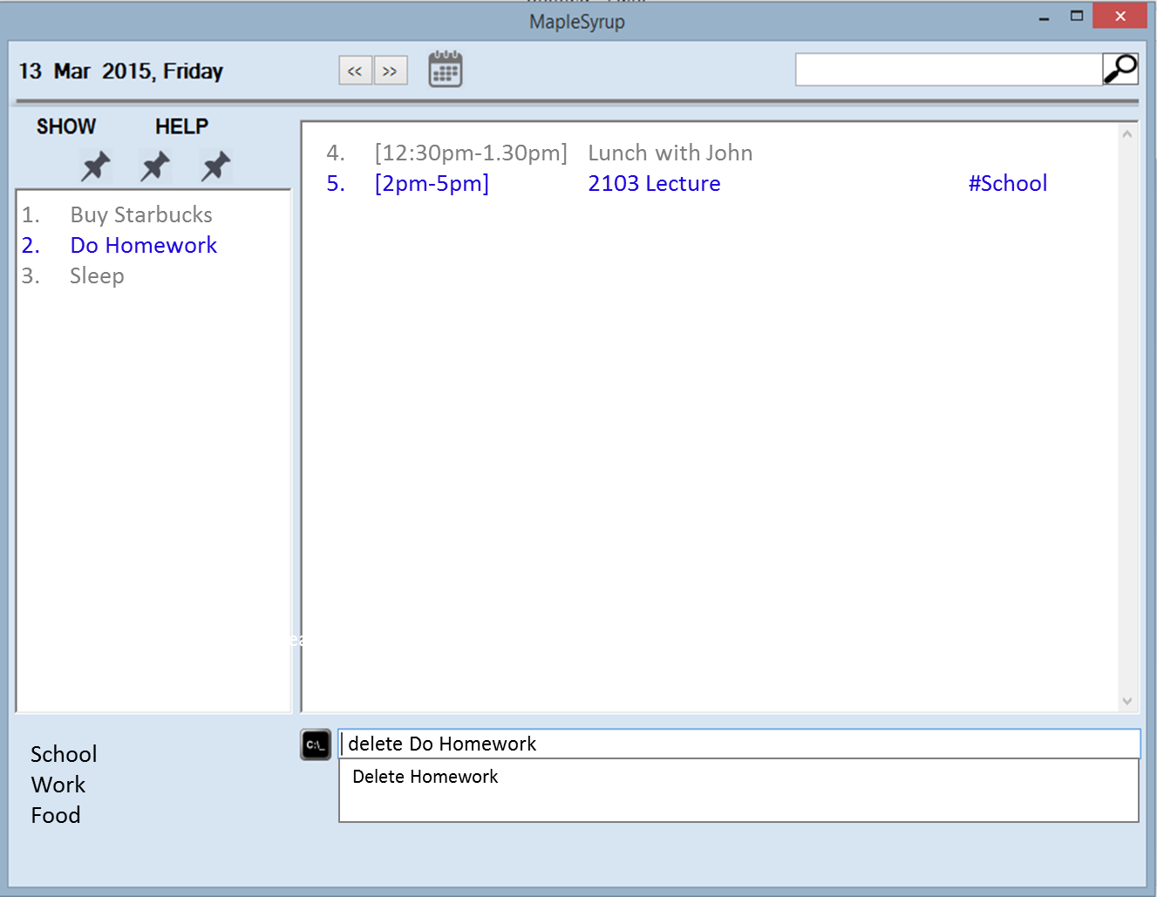

3. Feedback box will display an acknowledgement “2013 Lecture deleted.” As seen below.

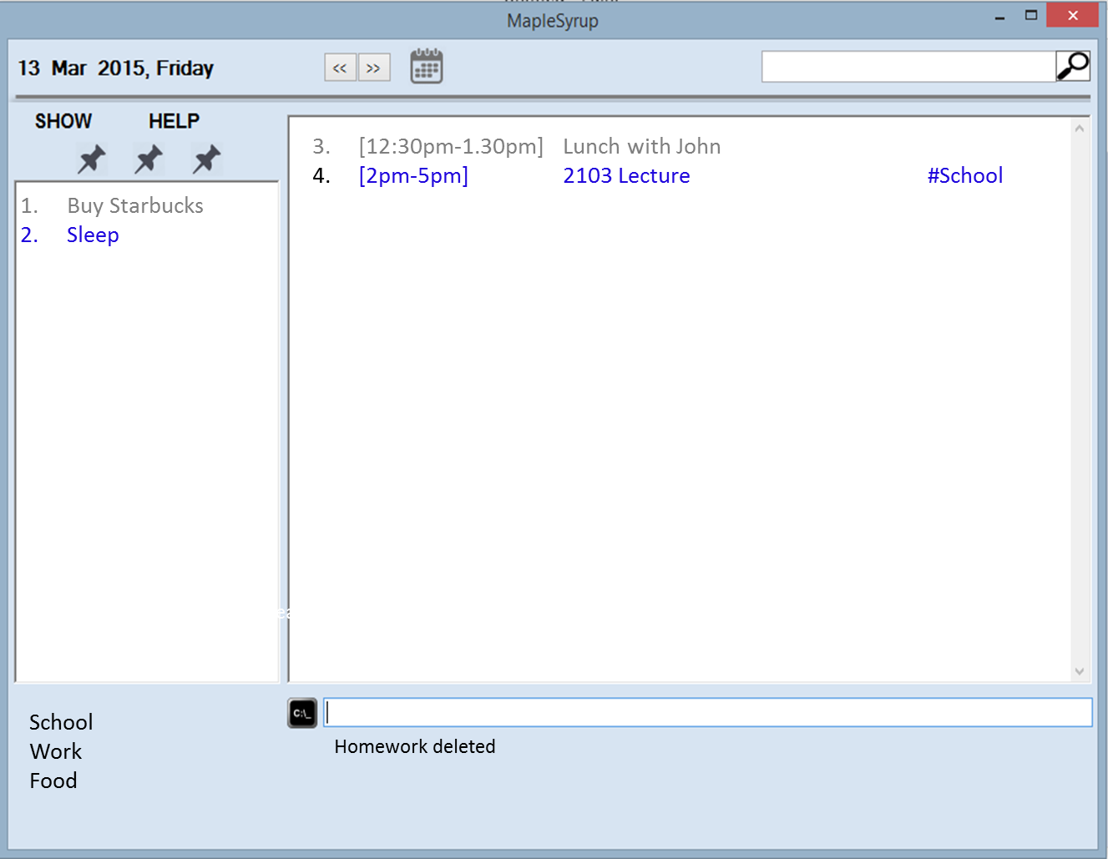

DISPLAYING EVENTS (BY SYSTEM DEFAULT CATEGORIES)- MONTH, WEEK, TODAY
To display a preset category, “Today”,”Week”,”Month”, move your cursor over to “SHOW” icon and press on the desired category. Alternatively, type “show today”, “show week”, “show month” into the command bar.

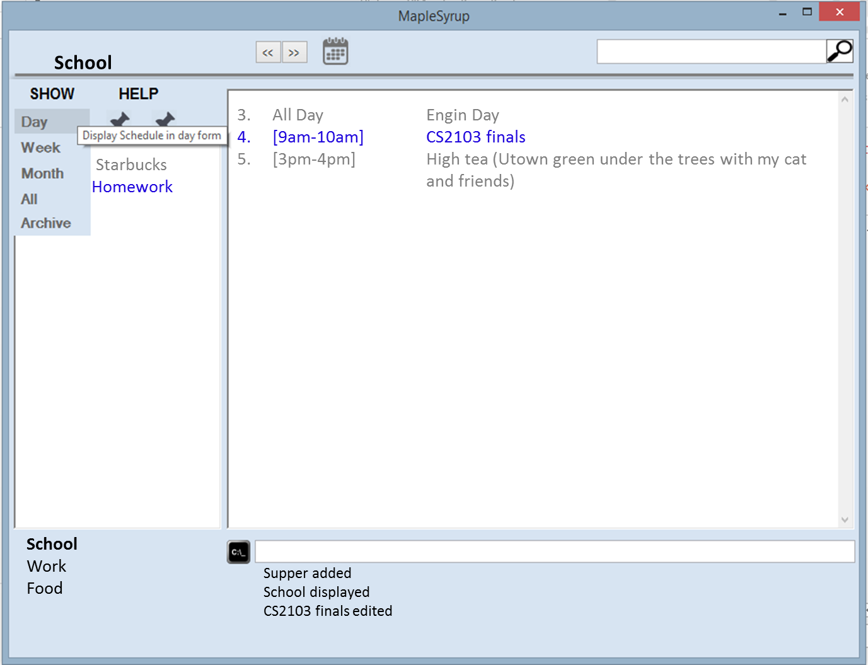

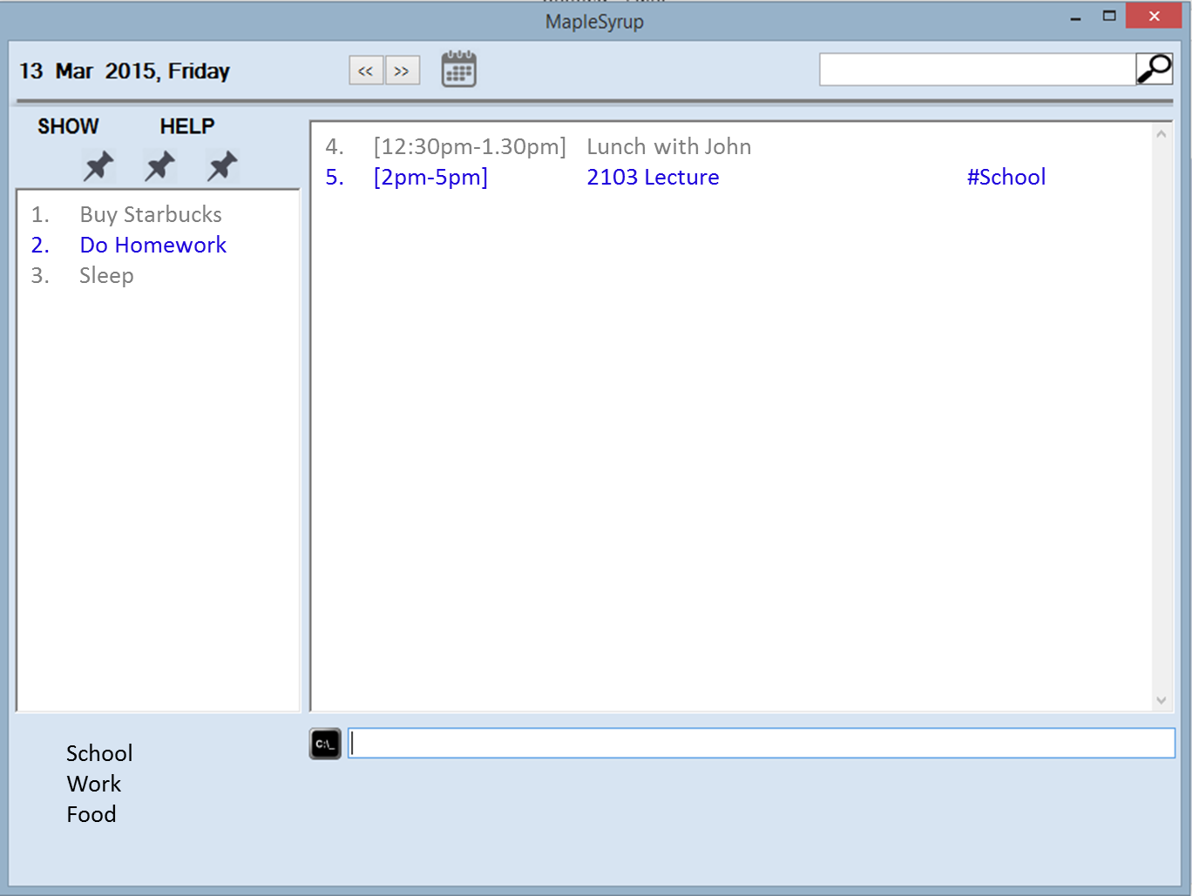

UNDO THE LAST ACTION
1. Simple move your cursor over to “HELP” and click ‘Undo’
2. Alternatively, you can also type “undo” on the command bar.
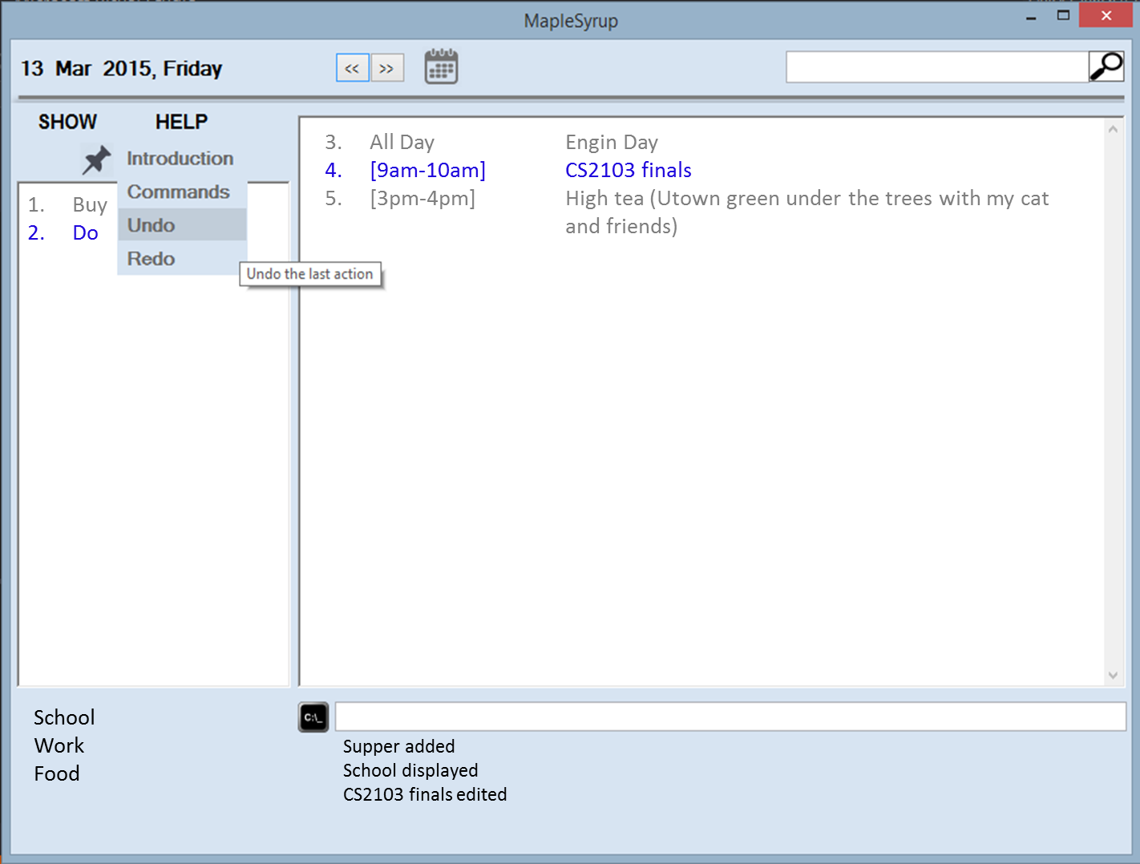
3. The feedback bar will display an acknowledgement statement as seen below.
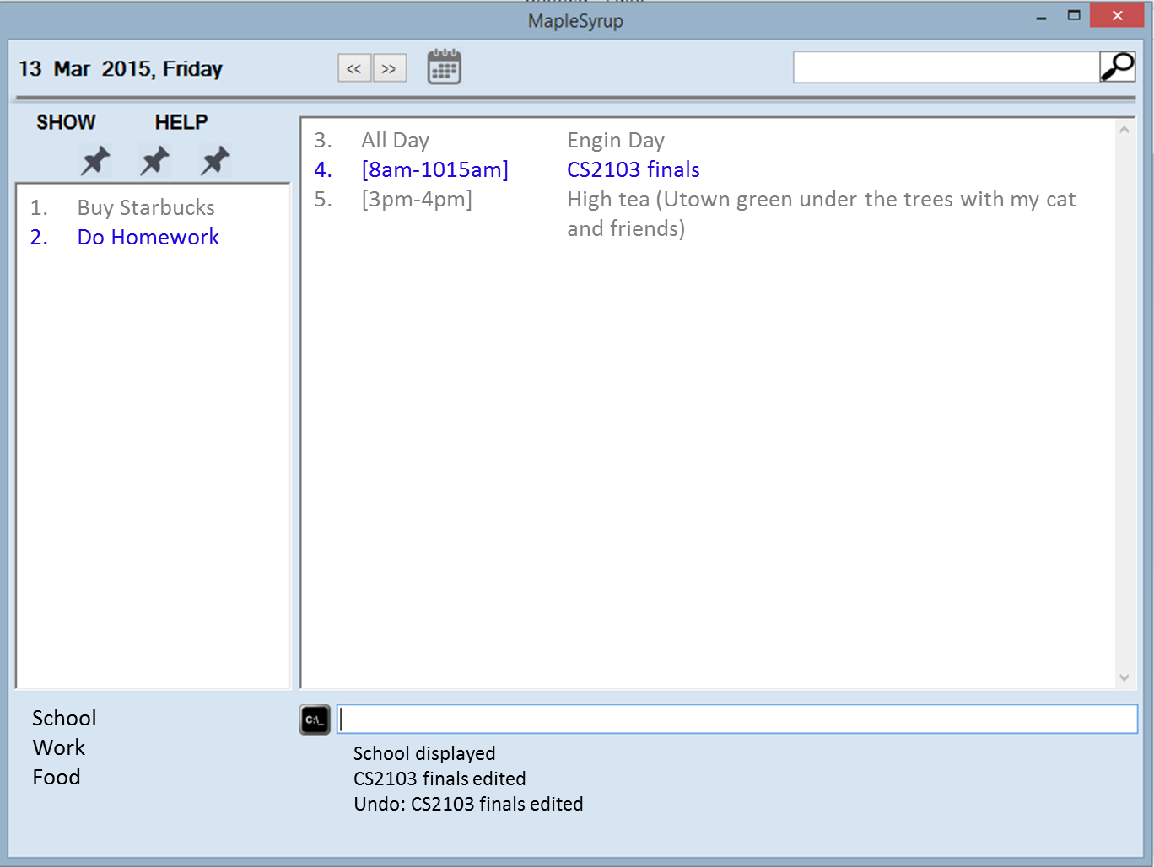

REDO THE LAST UNDO-ED ACTION
1. Simple move your mouse over to “HELP” and press ‘Redo
2. Alternatively, you can also type “Redo” on the command bar.

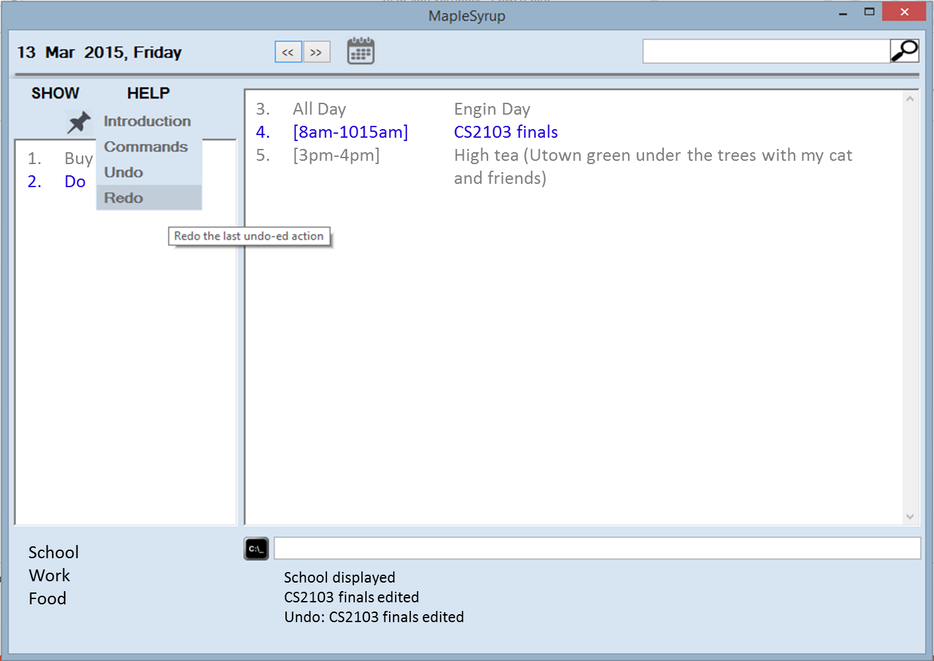
3. The feedback bar will display an acknowledgement statement as seen below.
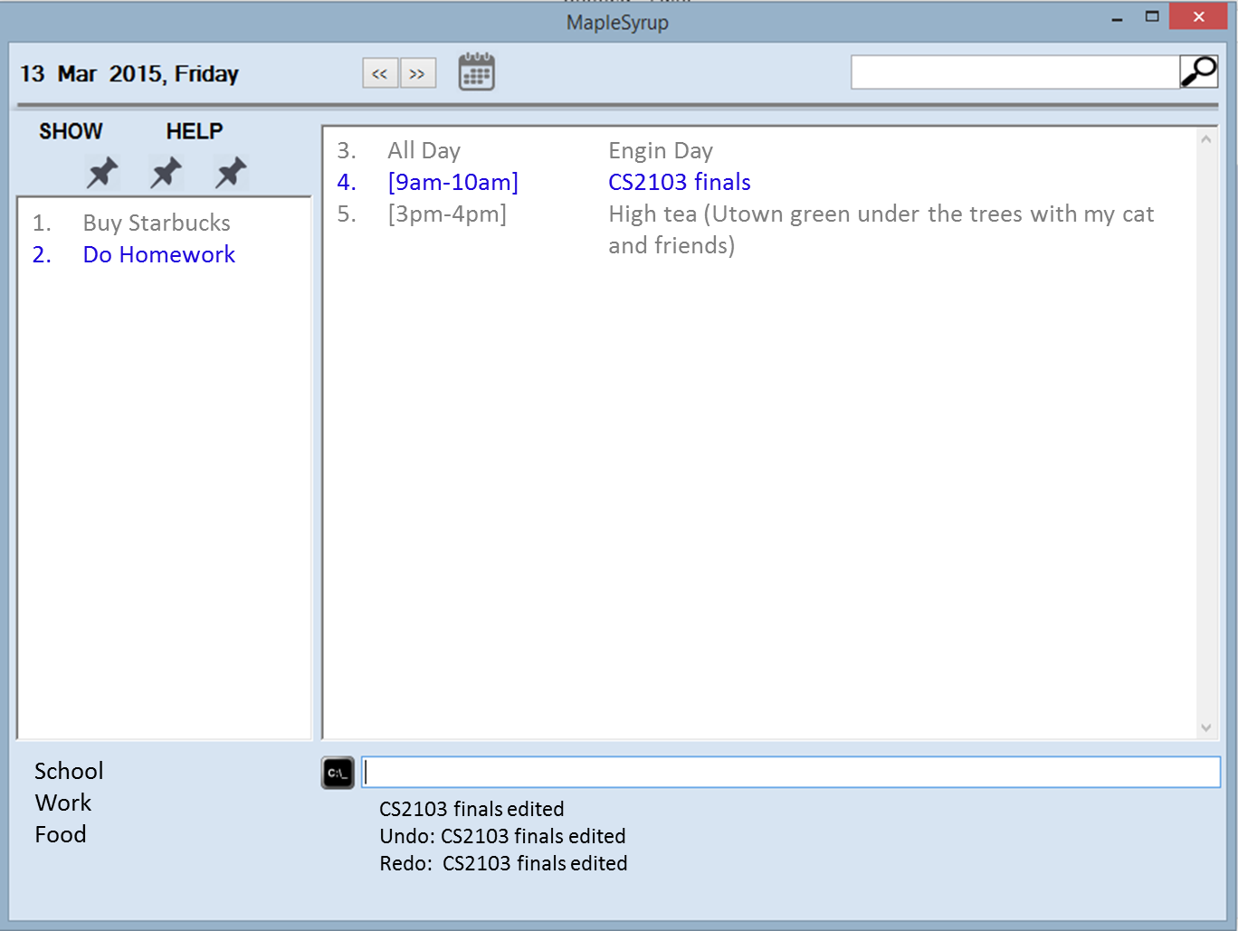

Appendix A: User stories. As a user, …

[Likely]
ID | I can … (i.e. Functionality) | so that I … (i.e. Value)
addFloating | add a task by specifying a task description only | can record tasks that I want to do some day
addLocation | Add location to an event | Will know where I need to be for that event
setRecurring | Set events to be recurring every day/week/month | Do not have to replicate similar events that occur every day/week/month
anyFormat | Enter new task in any format | Do not have to follow strictly to a certain format
setCategories | Organize my events/tasks by categories through tagging | Can search for any event/task easily
addAllDay | Add all day events | Do not have to specify time period spanning the whole day
setImportance | Rank my task by importance | Can sort tasks by importance and perform more important task first
viewAll | View all my task/events in an entire calendar | Can see how busy the week/month is going to be
setAbbreviations | Type in commands in the form of abbreviations | Save time by reducing amount of typing
setKeyboardCtrl | Open/close the software with keyboard commands | Have a quicker and simpler way of opening and closing the software
viewFreeSlots | View all free slots available | Better
setAutoSave | Save my inputs after every command | No loss of information if software accidentally closes
viewCompleted | View all completed tasks | Have a sense of accomplishment
reportClashing | Notified if there is any clashing events/tasks | Reschedule events/tasks to not have any clash
allowEdit | Edit my task information | Change any information at any time

[Unlikely]
ID | I can … (i.e. Functionality) | so that I … (i.e. Value)
addAlarm | Alarm/reminder when event is coming up | Will not miss important tasks
autoReschedule | Let the software auto reschedule my task if I fail to complete it during the set time | Do not need to set a new deadline again
setBufferTime | Set buffer time between events at different locations | Do not have a situation where I do not have time to travel from one event to the other
setAutoStart | Have the software auto start up when I turn on my computer | Can use the software immediately and be reminded of today’s event right away

Appendix B: Product survey

Product: Google Calendar Documented by: Ter Yong Kang
Strengths:
1. Event colour - allow user to classify events based on colour. This enhance the user experience.
2. Same event can be repeated more than 1 time.
3. Find time function - helps user to find a free time for the event to be added
4. Search function - allows user to search for events according to its details (name etc. etc.)
5. Display density allows user to choose the style of displaying calendar - enhances user experience
6. Displays only the important details of the event (Name & Time) on the summary page. Upon clicking the event, the full details of the event are being displayed. This provides a quick overview for the user without information overloading he/she.
7. A "help" section to provide a quick guide to new users on how to use the program
Weaknesses:
1. Unable to help user prioritise which event is most important given they overlaps
2. Unable to prioritise to user what event/activity to be complicated first
3. Does not allow user to add "floating tasks" without entering date and time
4. Unable to categorise events of the same type (e.g. work, family) together (except through colour)
5. Only able to display in Day Week Month 4Day. Should have more display options such as "display event according to priority" or "events of same type" etc.
Product: Macbook Calendar Documented by: George Lam Changwei
Strengths:
1. Able to add new events easily with detailed information such as location, day and time
2. Able to set alarms and reminder for to do events
3. Able to add invitees, notes, URL, attachments
4. Able to tag an item to sort by different categories.
5. Can sync to Iphone
Weaknesses:
1. Only on mac platform
2. Unable to recognise shortforms for users that prefers to type fast
Product: Wunderlist Documented by: Che Jian Yong Joshua
Strengths:
1. Able to set due date, and has options for recurring events daily, weekly, monthly, yearly, and even custom (every 2 days, or every 5 days)
2. Able to add additional details to the event
3. Able to star events to label as high priority.
4. Able to search for events based on event title as well as additional info typed on the event
5. Has sorting availability by due dates, and priority.
6. Has automatic grouping of events, by today and week.
7. Allows attaching of file to the event, such as emails or documents that contain additional information on the current event can be linked to
8. Has shortcuts available for quick addition, starring, completing, selecting
9. Keeps records of completed tasks for reference in the future if need be
Weaknesses:
1. Does not allow copying and pasting of events. Not able to set multiple due dates that does not follow a standard recurring structure.
2. Does not allow previewing of all the events in the form of a calendar for easier viewing. (Such as seeing how busy a certain week is)
3. Front page of website does not show all the events. Unable to set Today tab as the first tab viewed.
4. Events for the week cannot be sorted, fixed by due dates.
Product: Sony Calendar Documented by: Ong Wei Jee
Strengths:
1. Good GUI
2. Can view in day/week/month
3. Option to input location and detailed event description
4. Can specific exact time for events
5. Can set repetition for events
Weaknesses:
1. Setting time by scrolling through numbers is not efficient
2. Reminders only occur 10 minutes before the event
3. Must navigate to respective dates to view events, and it is not always obvious in the GUI

MapleSyrup Developer Guide

Table of Contents
Overall Architecture ................................................................................................................................ 1
GUI .......................................................................................................................................................... 2
Logic ........................................................................................................................................................ 3
Overview ............................................................................................................................................. 3
LogicExecutor ...................................................................................................................................... 3
LogicParser .......................................................................................................................................... 4
LogicData ............................................................................................................................................. 5
Command ............................................................................................................................................ 6
Command Execution Process .............................................................................................................. 7
Storage .................................................................................................................................................... 9
Task & State .......................................................................................................................................... 11
Task ................................................................................................................................................... 11
State .................................................................................................................................................. 12
Testing ................................................................................................................................................... 13

